TASK : 5
SAMPLE INPUT :-
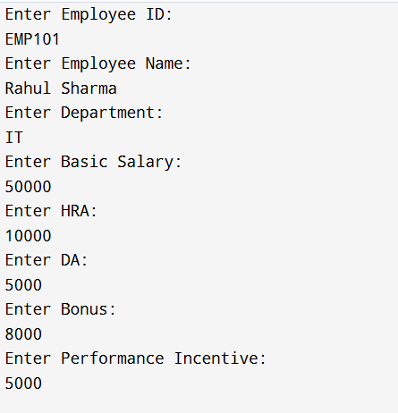
CODE:-
import 'dart:io';

// Base Class
class Employee {
String employeeId = "";
String employeeName = "";
String department = "";

void displayEmployeeInfo() {
print("Employee ID : $employeeId");
print("Name : $employeeName");
print("Department : $department");
}
}

// Child Class
class Salary extends Employee {
double basicSalary = 0;
double hra = 0;
double da = 0;
double bonus = 0;

double grossSalary = 0;
double tax = 0;
double netSalary = 0;

void calculateGrossSalary() {
grossSalary = basicSalary + hra + da + bonus;
}

void calculateTax() {
if (grossSalary > 80000) {
tax = grossSalary * 0.20;
} else if (grossSalary > 50000) {
tax = grossSalary * 0.10;
} else {
tax = 0;
}
}

void calculateNetSalary() {
netSalary = grossSalary - tax;
}

void displaySalarySlip() {
print("\n==========================================");
print(" EMPLOYEE SALARY SLIP");
print("==========================================\n");

displayEmployeeInfo();

print("\nBasic Salary : ₹$basicSalary");
print("HRA : ₹$hra");
print("DA : ₹$da");
print("Bonus : ₹$bonus");

print("\nGross Salary : ₹$grossSalary");
print("Tax : ₹$tax");
print("Net Salary : ₹$netSalary");

print("\n==========================================");
}
}

// Second Child Class
class SeniorEmployee extends Salary {
double performanceIncentive = 0;

@override
void calculateGrossSalary() {
grossSalary =
basicSalary + hra + da + bonus + performanceIncentive;
}

@override
void displaySalarySlip() {
print("\n==========================================");
print(" SENIOR EMPLOYEE SALARY SLIP");
print("==========================================\n");

displayEmployeeInfo();

print("\nBasic Salary : ₹$basicSalary");
print("HRA : ₹$hra");
print("DA : ₹$da");
print("Bonus : ₹$bonus");
print("Performance Incentive : ₹$performanceIncentive");

print("\nGross Salary : ₹$grossSalary");
print("Tax : ₹$tax");
print("Net Salary : ₹$netSalary");

print("\n==========================================");
}
}

void main() {
SeniorEmployee emp = SeniorEmployee();

print("Enter Employee ID:");
emp.employeeId = stdin.readLineSync()!;

print("Enter Employee Name:");
emp.employeeName = stdin.readLineSync()!;

print("Enter Department:");
emp.department = stdin.readLineSync()!;

print("Enter Basic Salary:");
emp.basicSalary = double.parse(stdin.readLineSync()!);

print("Enter HRA:");
emp.hra = double.parse(stdin.readLineSync()!);

print("Enter DA:");
emp.da = double.parse(stdin.readLineSync()!);

print("Enter Bonus:");
emp.bonus = double.parse(stdin.readLineSync()!);

print("Enter Performance Incentive:");
emp.performanceIncentive = double.parse(stdin.readLineSync()!);

emp.calculateGrossSalary();
emp.calculateTax();
emp.calculateNetSalary();

emp.displaySalarySlip();
}

OUTPUT :-


